 [Translated from Chinese (Simplified) to English - www.onlinedoctranslator.com](https://www.onlinedoctranslator.com/en/?utm_source=onlinedoctranslator&utm_medium=docx&utm_campaign=attribution)

**HS1-42**

**AC/DC pulse closed loop stepper driver**

**User Manual V1.0.0**

Shenzhen Gerui IoT Technology Co., Ltd.

**Table of contents**

1. Product Introduction 1

1.1 Product Overview 1

1.2 Product Features 1

1.3 Application Areas 1

2. Electrical, Mechanical and Environmental Indicators 2

2.1 Mechanical installation diagram 2

2.2 Enhanced heat dissipation 2

2.3 Electrical specifications 3

2.4 Operating environment and parameters 3

3. Driver interface and wiring introduction 4

3.1 Interface Diagram 4

3.2 Interface Description 4

3.2.1 Control signal interface 4

3.2.2 Output signal interface 5

3.2.3 Brake control interface (reserved) 5

3.2.4 Encoder interface 5

3.2.5 Motor control output interface 5

3.2.6 Power Input Interface 6

3.2.7 Burning and debugging interface 6

3.2.8 Status Indicator 6

3.3 Input control signal 7

3.3.1 Input control signal interface circuit 7

3.3.2 Control signal timing diagram 7

3.3.3 Control signal mode setting 8

3.4 Output control signal 8

3.4.1 AM interface is used for alarm and arrival output 8

3.4.2 BK interface controls the brake motor (reserved) 8

3.5 Wiring requirements 9

4. DIP switch function setting 10

4.1 Segmentation Settings 10

4.2 Direction Setting 11

4.3 Alarm polarity setting 11

4.4 Algorithm Selection 11

4.5 Smoothing coefficient setting 11

5. Power supply selection 12

6. Indicator lights and alarm indicators 13

VII. Warranty and After-sales Service 14

7.1 Warranty 14

7.1.1 Free warranty 14

7.1.2 Warranty exclusion 14

7.2 Exchange 14

7.2.1 Replacement of defective product 14

7.2.2 Exchange for non-product failure 15

7.3 Returns 15

7.4 After-sales service 15

8. Version Revision History 15

# Product Introduction

## 1.1 Product Overview

HS1-42 AC/DC pulse closed-loop stepper driver is the latest model, using the latest dedicated motor control digital signal processor, is an advanced motion control device, combining the advantages of traditional stepper driver and closed-loop feedback system. It can provide higher precision, greater torque output and lower drive noise.

HS1-42The brake output control function is reserved. Within the working voltage range, it can stably output about DC24V voltage. Users can directly connect the brake power line (pay attention to distinguish between positive and negative), and no external relays or other devices are required in the middle, which can greatly facilitate user use.

HS1-42With serial port debugging function, communication adoptsMINI USBInterface, users can set various parameters such as subdivision, current, working mode, etc. through the PC host debugging software, which greatly enriches the practical functions of the product and can meet the application of most occasions.

## 1.2 Product Features

●Small size, easy to install

●The brake output control interface is reserved, and relay intermediate control is not required

●New generation 32-bit DSP technology, good stability, strong compatibility and high cost performance

●External dial to set driver subdivision, initial direction, alarm polarity, algorithm, smoothing coefficient

Optically isolated differential signal input

●Built-in micro-segmentation, excellent low-speed stability

●The impulse response frequency can reach up to 200KHz (higher can be modified)

●Subdivision setting range 400-60000 (can be set by the host computer)

●Precise current control greatly reduces motor heating

●Low vibration and low noise

●With over-voltage, over-difference and other alarm protection functions

Input voltage range:DC 24V~50V /AC 18V~36V

## 1.3 Application Areas

Suitable for various small and medium-sized automation equipment and instruments, such as: engraving machines, marking machines, cutting machines, plotters, CNC machine tools, automatic assembly equipment, etc. It has a particularly good application effect in equipment applications where users expect low noise and high speed.

# Electrical, Mechanical and Environmental Specifications

## 2.1 Mechanical installation diagram

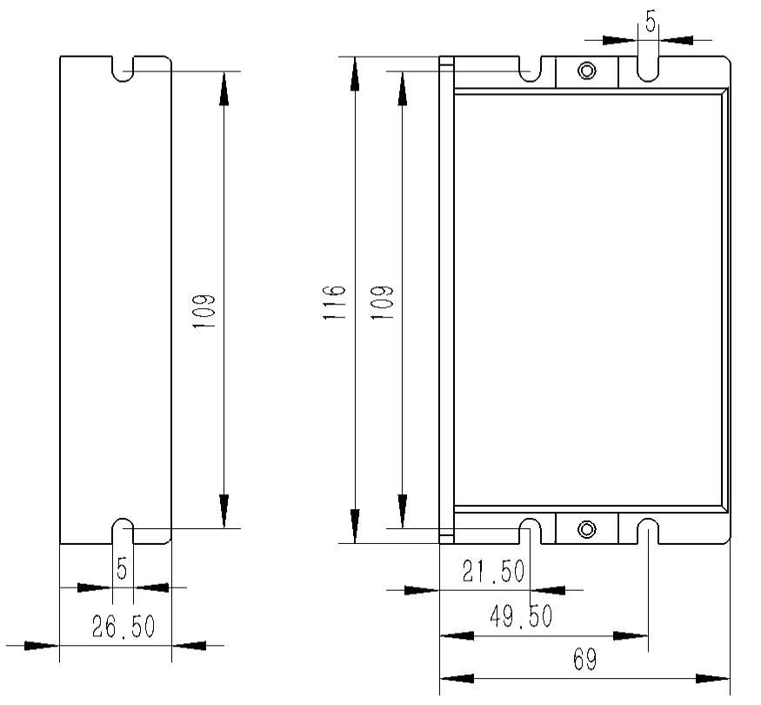

Side installation diagram Front installation diagram

Figure 2.1 Installation dimensions (unit: mm)

**It is recommended to use side installation for better heat dissipation. When designing the installation dimensions, the size of the wiring terminals and the wiring should be considered.**

## 2.2 Enhanced heat dissipation

1. The reliable operating temperature of the driver is usually within 50℃, and the operating temperature of the motor is within 80℃;
2. When installing the driver, please install it sideways and allow strong air convection to form on the bottom of the driver. If necessary, install a fan near the driver inside the machine to form air convection to assist in heat dissipation and ensure that the driver operates within a reliable operating temperature range.

## 2.3 Electrical specifications

|  |  |  |  |  |
| --- | --- | --- | --- | --- |
| **illustrate** | **HS1-42** | | | |
| **Minimum** | **Typical Value** | **Maximum** | **unit** |
| **Input DC power supply voltage** | 24 | twenty four | 50 | VDC |
| **Input AC power voltage** | 18 | 18 | 36 | VDC |
| **Control signal input current** | 7 | 10 | 16 | mA |
| **Step pulse frequency** | 0 | - | 200 | KHz |
| **Insulation resistance** | 50 |  |  | MΩ |

## 2.4 Operating environment and parameters

|  |  |  |
| --- | --- | --- |
| **Cooling method** | | **Natural cooling, fan cooling** |
| **Usage Environment** | **occasion** | Do not place it near other heating equipment. Avoid dust, oil mist, corrosive gas, high humidity and strong vibration. Flammable gas and conductive dust are prohibited. |
| **temperature** | 0——50℃ |
| **humidity** | 40-90%RH |
| **vibration** | 10~55Hz/0.15mm |
| **Storage temperature** | | -20℃~65℃ |

# Driver interface and wiring introduction

## e34c071f1c00ec7001c2e6a3e6600763.1 Interface Diagram

Figure 3.1 HS1-57 interface diagram

## 3.2 Interface Description

HS1-42The power interface of the AC/DC pulse closed-loop stepper driver uses a 3.81-3P terminal block, the signal control interface uses a 3.81-8P terminal block, the encoder uses a 3.81-6P terminal block, and the motor interface uses a 3.81-4P terminal block. The specific definitions of the interfaces are described in the following sections.

### 3.2.1 Control signal interface

|  |  |
| --- | --- |
| **name** | **Function** |
| **PU+** | Pulse control signal: +5V-+24V can be driven, rising edge is effective, every time the pulse changes from low to high, the motor takes a microstep. In order to reliably respond to the pulse signal, the pulse width should be greater than 2.5μs. |
| **PU-** |
| **DR+** | Direction control signal: can be driven by +5V-+24V, high/low level signal. To ensure reliable commutation of the motor, the direction signal should be established at least 50μs before the pulse signal. |
| **DR-** |
| **EN+** | Enable control signal: +5V-+24V can be driven, high/low level signal. Used to enable or disable the operation of the motor. When EN+ is connected to +5V and EN- is connected to a low level, the driver will cut off the current of each phase of the motor to put the motor in a free state, and the step pulse will not be responded to at this time. When this function is not needed, the enable signal terminal can be left floating. In addition, the EN terminal can also be used to clear the out-of-tolerance alarm signal. |
| **EN-** |

### 3.2.2 Output signal interface

The output signal interface is used as the alarm output function by default. When an overvoltage or position error alarm occurs, the output signal is valid. In addition, the output interface can also be set to the in-position output function through the PC host software. Users can make corresponding settings according to actual usage.

|  |  |
| --- | --- |
| **name** | **Function** |
| **AM+** | Alarm signal output: When over-pressure or position out-of-tolerance alarm occurs, the alarm signal output is valid;  Maximum driving current 50mA. |
| **AM-** |

### 3.2.3 Brake control interface (reserved)

|  |  |
| --- | --- |
| **name** | **Function** |
| **BK+** | Brake control signal output: When over-voltage or position out-of-tolerance alarm occurs, the BK port output signal is valid to control the brake;  This function is temporarily reserved. If you have such needs, please contact us to add it. |
| **BK-** |

### 3.2.4 Encoder interface

|  |  |
| --- | --- |
| **name** | **Function** |
| **PB+** | Encoder B phase input interface, please pay attention to the line sequence. |
| **PB-** |
| **PA+** | Encoder A phase input interface, please pay attention to the line sequence. |
| **PA-** |
| **VCC** | Encoder 5V power supply positive terminal. |
| **GND** | Negative terminal of the encoder 5V power supply. |

### 3.2.5 Motor control output interface

|  |  |  |  |  |
| --- | --- | --- | --- | --- |
| **name** | | **color** | **illustrate** | **Function** |
| **Motor** | **A+** | **red** | Motor interface | Two-phase stepper motor wiring port, pay attention to the line sequence |
| **A-** | **blue** |
| **B+** | **green** |
| **B-** | **black** |

### 3.2.6 Power Input Interface

|  |  |  |  |
| --- | --- | --- | --- |
| **name** | | **illustrate** | **Function** |
| **Power** | **V+/AC1** | Power interface | Power Input  DC24V~50V/AC18V~36V |
| **V-/AC2** |

### 3.2.7 Burning and debugging interface

HS1-42The serial communication interface of the driver adopts MINI USB interface, which can be connected to PC through the dedicated debugging line provided by our company via USB to TTL serial port conversion tool. It is forbidden to plug and unplug under power! On the PC side, customers can set the required parameters, such as current, subdivision, working mode, etc. For details, please refer to the upper computer software interface.

|  |  |  |  |
| --- | --- | --- | --- |
| **Terminal No.** | **symbol** | **name** | **illustrate** |
| **1** | **NC** | - | Internal Use |
| **2** | **NC** | - | Internal Use |
| **3** | **GND** | Serial communication address | 0V |
| **4** | **NC** | - | Internal Use |
| **5** | **NC** | - | Internal Use |
| **6** | **NC** | - | Internal Use |
| **7** | **RxD** | Serial port receiving end |  |
| **8** | **TXD** | Serial port sender |  |

▶Note: HS1-**42The debugging line connected to the PC is a dedicated line (provided according to user needs). Please check before use to avoid damage.**

### 3.2.8 Status Indicator

HS1-42The indicator light of the AC/DC pulse type closed-loop stepper driver is a retracted chip LED, and its basic definition is shown in the following table.

|  |  |  |
| --- | --- | --- |
| **name** | **Function** | **illustrate** |
| Green LED | Power supply, save parameter function indication, restore factory settings function indication, dial status switch,  Alarm indicator light | When the power is on normally, the green light is always on and the red light is off. When saving parameters, restoring factory settings, switching the dial status, or when the device is abnormal, the red and green lights flash alternately to give an alarm. For the flashing pattern, seesixchapter; |
| Red LED |

## 3.3 Input control signal

### 3.3.1 Input control signal interface circuit

HS1-42The driver control signal end adopts a differential interface circuit, which is applicable to differential signals, single-ended common cathode and common anode interfaces, and has a built-in high-speed photocoupler, which has strong anti-interference ability in harsh environments. The interface circuit diagram is shown in Figure 3.2.

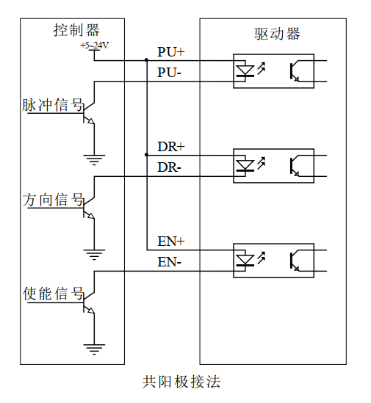 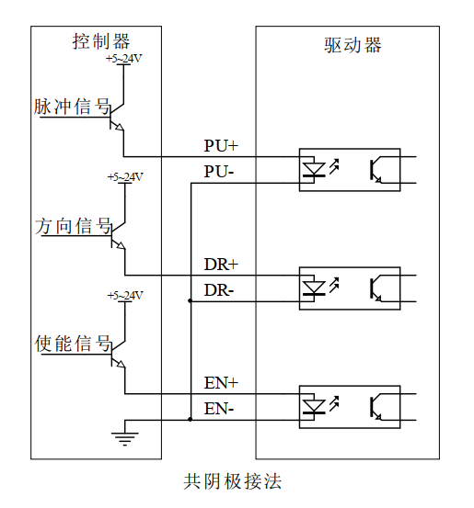

Figure 3.2 Input interface circuit

▶Note: HS1-**42It is a 5V-24V universal driver, so the signal control end does not need a series resistor!**

### 3.3.2 Control signal timing diagram

In order to avoid some malfunctions and deviations, PU, ​​DR and EN should meet certain requirements, as shown in the following figure:

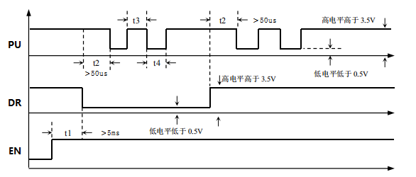

Figure 3.3 Control signal timing diagram

**Notes:**

1. t1: EN (enable signal) should be at least 5ms ahead of DR and confirmed to be high. In general, it is recommended that EN+ and EN- be left floating.
2. t2: DR determines its state as high or low at least 50μs in advance of the falling edge of PU.
3. t3: The pulse width is at least 2.5μs.
4. t4: Low level width is not less than 2.5μs.

### 3.3.3 Control signal mode setting

Pulse trigger edge selection: The rising edge or falling edge of the pulse can be set to trigger effectively through the PC software.

## 3.4 Output control signal

After the driver is powered on normally, the effective state of the output interface is initially defaulted to normally open output.Users can also configure the effective state of the output interface to normally closed output by default through the PC host software.

### 3.4.1 AM interface is used for alarm and arrival output

The following figure is a wiring diagram for the output signal port when used as an alarm output function (the connection method is the same when used as a position output):

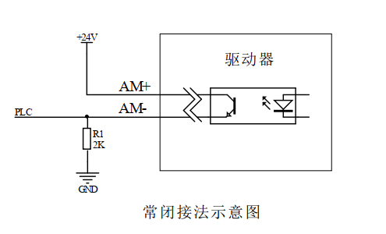

Figure 3.4 Schematic diagram of normally closed connection of output interface

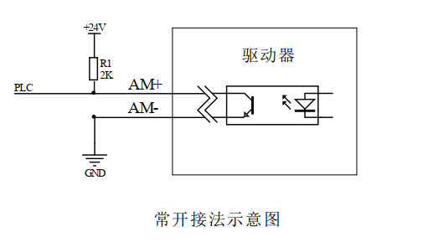

Figure 3.5 Schematic diagram of normally open connection of output interface

### **3.4.2BK interface controls the brake motor (reserved)**

HS1-42The output port of the AC/DC pulse closed-loop stepper driver includes the control function of the brake motor brake, which can directly control the brake holding and release. The following figure is a schematic diagram:



Figure 3.6 Brake motor brake wiring diagram

The specific control process is as follows: When the driver is poweredThe effective state of the output interface is initially set to normally open output by default. At this time, the brake is in the holding state. When the driver is powered on and stable, and the motor locks the shaft normally, it switches to the normally closed state to control the brake to release.If the driver generates an overvoltage or over-tolerance alarm, the brake will be controlled to engage again..

## 3.5 Wiring requirements

1. In order to prevent the driver from being interfered, it is recommended that the control signal use shielded cable, and the shield layer is short-circuited with the ground wire. Except for special requirements, the shield line of the control signal cable is grounded at one end: the host computer end of the shield line is grounded, and the driver end of the shield line is suspended. Only the same point is allowed to be grounded in the same machine. If it is not a real ground wire, there may be serious interference. In this case, the shield layer is not connected.
2. The pulse and direction signal lines are not allowed to be wrapped side by side with the motor lines. It is best to separate them by at least 10 cm. Otherwise, the motor noise will easily interfere with the pulse direction signals and cause inaccurate motor positioning, system instability and other faults.
3. If one power supply supplies multiple drives, they should be connected in parallel at the power supply. Chain connection from one drive to another is not allowed.
4. It is strictly forbidden to plug or unplug the high-voltage terminals of the driver while it is powered on. When the motor is stopped, there is still a large current flowing through the coil. Plugging or unplugging the terminals while it is powered on will cause a huge instantaneous induced electromotive force that will burn out the driver.
5. It is strictly forbidden to connect the wire end to the terminal after tinning it, otherwise the contact resistance may increase and the terminal may be damaged by overheating.
6. The wiring ends must not be exposed outside the terminals to prevent accidental short circuits and damage to the driver.

# DIP switch function setting

HS1-42The driver uses an 8-bit DIP switch to control the driver and motor. The detailed description is as follows:

|  |  |  |  |  |  |  |  |  |  |
| --- | --- | --- | --- | --- | --- | --- | --- | --- | --- |
| **SW1** | **SW2** | **SW3** | **SW4** | **SW5** | | **SW6** | | **SW7** | **SW8** |
| Segment settings | | | | | direction | | Alarm polarity | Algorithm selection | Smoothing coefficient |

## 4.1 Segmentation Settings

SW1-SW4 sets the subdivision of the driver. There are 16 subdivisions that can be set. The dials correspond to the default subdivision settings, as shown in the following table:Can also be set via PC softwareAnySubdivision size.

|  |  |  |  |  |  |
| --- | --- | --- | --- | --- | --- |
| **Steps/turn** | **SW1** | **SW2** | **SW3** | **SW4** | **illustrate** |
| 400 | on | on | on | on | When SW1-SW4 are all off,Users can use PC softwareset upThe size of the subdivision can be set in the range of 200-60000.The resolution is 1. |
| 800 | off | on | on | on |
| 1600 | on | off | on | on |
| 3200 | off | off | on | on |
| 6400 | on | on | off | on |
| 12800 | off | on | off | on |
| 25600 | on | off | off | on |
| 3600 | off | off | off | on |
| 1000 | on | on | on | off |
| 2000 | off | on | on | off |
| 4000 | on | off | on | off |
| 5000 | off | off | on | off |
| 8000 | on | on | off | off |
| 10000 | off | on | off | off |
| 20000 | on | off | off | off |
| 7200 | off | off | off | off |

## 4.2Direction settings

SW5Set the initial rotation direction of the motor. When SW5=off, it rotates in the forward direction; when SW5=on, it rotates in the reverse direction.

**▶Note: After the direction setting dial is modified, it needs to be powered on again for it to take effect.**

## 4.3 Alarm polarity setting

SW6 sets the default output signal resistance state of the alarm. When SW6=off, it is normally open; when SW6=on, it is normally closed.

## 4.4 Algorithm Selection

SW7 is used to select the control algorithm of the driver. When SW7=off, it is algorithm A; when SW7=on, it is algorithm B.

## 4.5 Smoothing coefficient setting

SW8 is used to select the smoothing coefficient. When SW8=off, the smoothing coefficient is 1; when SW8=on, the smoothing coefficient is 2.

# Power supply selection

The power supply voltage can work normally within the specified range. The HS1-57 driver can be powered by a transformer. It is recommended that the AC output voltage of the transformer does not exceed its specified maximum voltage.42The driver can also be powered by an unregulated DC power supply, but be careful to ensure that the peak voltage ripple after rectification does not exceed the specified maximum voltage. It is recommended that users use a DC voltage lower than the maximum voltage to avoid grid fluctuations exceeding the driver's operating voltage range.

If a voltage-regulated switching power supply is used, it should be noted that the output current range of the switching power supply must be set to the maximum.

**Notice:**

1. When wiring, pay attention to the position of the power interface and do not connect it to the motor port. After connecting, it is best to confirm whether it is connected correctly;
2. It is best to use an unregulated power supply;
3. When using an unregulated power supply, the power supply current output capacity should be greater than 60% of the driver set current;
4. When using a voltage-regulated switching power supply, the output current of the power supply should be greater than or equal to the operating current of the driver;
5. To reduce costs, two or three drivers can share one power supply, but the power supply must be large enough.

# Indicator lights and alarm indicators

HS1-42 AC/DCThe pulse type closed loop stepper driver has a green LED and a red LED. One can be used as a power indicator, and the other can be used as a fault indicator, a dial status switch indicator, or a parameter save or restore indicator. The specific relationship is shown in Table 6.1 below:

When the driver is powered on, the green LED is always on, and when the driver is powered off, the green LED is off.

When the DIP switch is turned, the green LED will flash twice quickly. This is normal and indicates that the DIP state switch is valid.

When the drive fails, the red and green lights flash alternately, and different flashing patterns indicate different fault information. When the fault is eliminated by the user, the green LED remains on and the red LED goes out.

When saving/restoring parameters, the red and green lights flash alternately in a cycle. When saving/restoring parameters is completed, the green LED is always on and the red LED is off.

Table 6.1 LED status indication

|  |  |  |  |
| --- | --- | --- | --- |
| **Number of LED flashes** | | **Phenomenon** | **illustrate** |
| Green LED | Red LED | After the green light flashes, the red light flashes |  |
| 0 | - | Green light is always on, red light is off | Driver Enable |
| 1 | - | Green light flashes, red light off | Receive pulse signal |
| 1 | 1 |  | Normal out-of-tolerance alarm |
| 2 | 1 |  | Pulse received in disabled state |
| 3 | 1 |  | (Overpressure) out-of-tolerance alarm |
| 1 | 4 |  | Overpressure alarm |
| 1 | 2 |  | Restoring parameters |
| 2 | 2 |  | Saving parameters in progress |

# Warranty and after-sales

## 7.1 Warranty

### **7.1.1 Free warranty**

Our company solemnly promises that for all products purchased from our company, if they are damaged due to the product itself during use, we will provide one year of free repair service. The round-trip shipping cost of the product shall be borne by both parties in half.

### **7.1.2 Warranty exclusion**

1. The driver is damaged due to the customer's own wiring error;
2. The drive is damaged due to exceeding the rated working voltage;
3. The DC power supply driver is connected to the AC power supply, causing the driver to be damaged;
4. The driver is damaged due to the customer's extremely harsh on-site environment, such as humidity, extreme cold, extreme heat, etc., without informing our company in advance;
5. The customer dismantles the drive housing without permission or the serial label number is torn off;
6. 15 days after the customer confirms receipt, the housing is obviously damaged or hit, resulting in damage to the drive;
7. Forceful natural disasters, such as fire, earthquake, tsunami, typhoon, etc.;

In the above cases, our company will charge a certain amount of repair cost after evaluating the interests of all parties. In other cases, repairs will be provided free of charge forever.

## 7.2 Exchange

### **7.2.1 Replacement of defective product**

For faults in new products, our company provides three months of free replacement service.

After our technical support staff confirms that the problem is with the product itself, they will send the product back to our company to avoid wasting time and postage on the round trip. Customers need to send the faulty product back by express or logistics first, and our company will send another new product back to the customer as soon as possible after receiving it.

**Notice:**All our products undergo rigorous testing and aging before leaving the warehouse, so it is extremely rare for new products to malfunction. Please be sure to read the instructions carefully or consult our technical support staff when operating, or our technical support staff will remotely assist customers in operating.

* **Please note the following points when exchanging goods:**

(1) Please ensure that the package is complete when sending it back to avoid damage during transportation;

(2) Please ensure that the attached accessories are complete when exchanging the product;

(3) Each driver should be packaged independently in its original outer box to avoid secondary damage to the product during transportation;

(4) If the driver is returned and it is confirmed that the fault is not due to product failure, but rather due to the customer's negligence in operation, which led to the customer mistakenly thinking that the driver is faulty, the company will not bear the shipping costs (the customer's negligence in operation includes: the driver is damaged due to wrong wiring, the driver is mistakenly thought to be damaged due to poor wiring, the driver cannot be used normally due to operation errors, etc.).

### **7.2.2 Exchange for non-product failure**

If the customer is not satisfied with the appearance or function of the product received and wants to replace it with a better driver, he or she can apply for a replacement service from our company within one week of receiving the product. After verification, our company will return the product. If the returned product is confirmed to be undamaged, with complete accessories and good packaging, the company will replace it with another product for the customer. For the replaced product, if there is a price difference, the customer will make up the difference.

**Note: The replaced product will no longer be eligible for the non-product fault replacement service. The round-trip shipping costs and other costs incurred by the non-product fault replacement service shall be borne by the customer!**

## 7.3 Returns

Our company provides a 7-day return service for products with quality problems. If you find quality problems with the product within 7 days of receiving the product (based on the actual date of receipt by the customer), please communicate with our salesperson or technical support personnel in time. After our technical support personnel confirms that it is a quality problem of the company's product itself, the customer can send the original complete product and its inner and outer packaging, accessories and shipping order back to our company by express or logistics.

If the customer still insists on returning the goods after our company has checked and confirmed that they are correct, the round-trip shipping costs and all other costs incurred shall be borne by the customer.

* **Please note the following points when returning goods:**

(1) Please contact the relevant department of our company before making a refund;

(2) The product must be in new condition and intact packaging. Please send it back to our company by express or logistics;

(3) We will not accept any complaints caused by customers, such as product appearance damage, incomplete accessories, etc.

## 7.4 After-sales service

If you need after-sales service support when using this product, please contact our company as soon as possible.

National free service hotline: 0755-23206995;

Technical specialist service hotline: 18576758897 (Mr. Xie), 17666115681 (Mr. Tuo);

Service hours: 8:30-17:30, Monday to Friday (except national holidays).

# Revision History

|  |  |  |  |
| --- | --- | --- | --- |
| **Version Number** | **illustrate** | **Modify deadline** | **Preparer/Reviewer** |
| V1.0.0 | Initial use version; | 2024.04.twenty four | WH, JQ/TCJ |